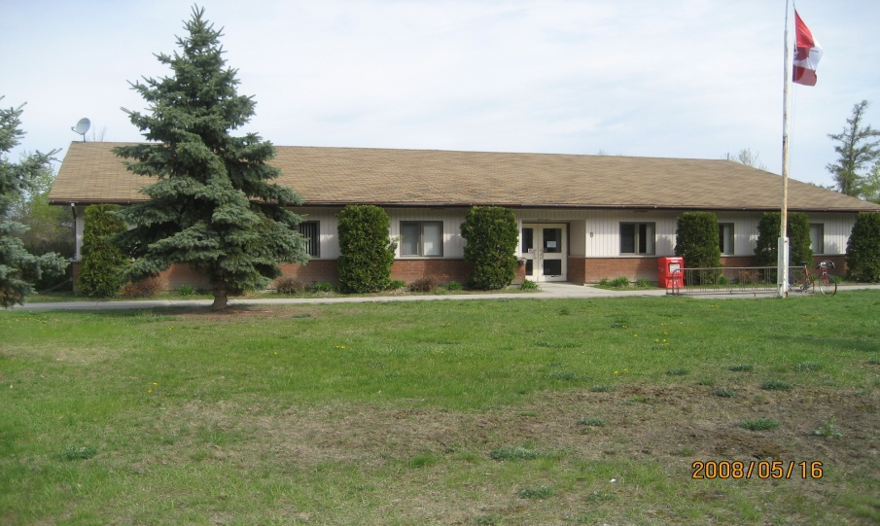
2014-2019

Conservation and Demand Management Plan Energy Consumption

5 Year Energy Conservation & Demand Management
Table of Contents

Introduction...................................................................................3

Goals & Objectives........................................................................3

Municipal Office/Library.............................................................4

Public Works.................................................................................5

Fire Hall.........................................................................................5

Four Season’s Waterfront Complex............................................6

Water Pumping Stations/Sewage Lift/Lagoon...........................7

Energy Overview 2012..................................................................8

Introduction
The Town of Spanish is located in the Algoma District along Trans-Canada Highway 17 at the mouth of the Spanish River on the North Channel of Lake Huron. We are a small rural community with a population of 696.

Ontario Regulation 397/11 made under the Green Energy Act, 2009, requires that every public agency shall prepare, publish and make available to the public and implement energy conservation and demand management plans. The required elements of the Plan include the following:
- Information on the municipality’s annual energy consumption during the last year for which complete information is available for a full year;
- The municipality’s goals and objectives for conserving and otherwise reducing energy consumption and managing its demand for energy;
- The municipalities proposed measures under its Plan, the cost and saving estimates for these proposed measures and the estimated length of time these measures will be in place;
- A description of any renewable energy generation facility operated by the municipality and the amount of energy produced on an annual basis by the facility;
Spanish is prescribed as a public agency and therefore is required to record the annual energy consumption of their buildings. The municipality has taken measures to conserve and reduce energy consumption and manage the demand for energy. It is imperative that the energy efficiency of the Spanish municipal buildings continue to be improved due to the rising fuel costs, energy security and environmental concerns. Energy savings efforts focus on electrical, heating and cooling consumption to create potential savings.

Goals and Objectives
The objective is to improve our energy efficiency and lower costs while continuing to meet the needs of the municipality.
The goals are:
- To ensure that employees are more aware of the need for energy conservation and make every effort to reduce energy consumption;
- To explore opportunities that may be available at a reasonable cost vs. benefit to reduce energy consumption;
- To seek funding to increase energy efficiency of our municipal facilities.

Municipal Office and Library

The municipal building houses the Town o f Spanish administration offices, Council Chambers and the Spanish Public Library, and is located at 8 Trunk Road, Spanish. The facility was built in 1992, and has provided 22 years of service. It is a one level block building. The municipal office is open five days a week, [40 hours] and the Library operates 29 hours per week, with 4 of those hours in the evening. Council meetings are held twice per month in the evenings, with special meetings as needed. The lighting was upgraded to efficient fluorescents about five years ago. All areas of the building are controlled with programmable thermostats whereby the heating/cooling is adjusted after working works. All lights are turned off when the building is not in use. Weather stripping will be checked around the windows and doors and replaced as required. This building is heated with three propane furnaces.

Public Works

The Public Works building was erected in 1991 and houses the public works employees [3 full time] and students in the summer. It has provided 23 years of service to date. It is also a block building and is heated via propane heaters which are mounted on the ceiling.
The florescent lighting system was upgraded as well about five years ago.
This building houses the grader, and other heavy equipment which is stored inside during the winter months. The building has two large overhead doors at either end of the building, which contributes to heat loss if left open for any extended time during the winter months. Staff is made aware of the important to keep these doors closed and opened for immediate use of moving vehicles in and out only.
Ceiling fans are scheduled to be installed in the Fall of 2014 to assist with the distribution of heat in the winter months.

Fire Hall

The Fire Hall was constructed in 1976 and is a two bay facility, which originally housed both public works and the fire department. In 1991 the public works department moved into their own facility leaving this building strictly for fire use. The building currently houses three fire response vehicles. It has an area at the upper rear of the building that houses a training room for volunteers. Training takes place every second Tuesday.
Other than this there is very little activity at this building. Again the building has two overhead doors, which would be activated during a response to a call, or for on hands training. The building is heated by way of a ground source heat pump that was installed in the early nineties. The doors have had repairs conducted to the weather stripping and the floor surface adjusted to ensure proper closure.

Four Season’s Waterfront Complex [adjacent to a full service 125 slip marina]

This large two story complex was constructed in 1999, as an energy efficient building. The building is constructed with energy efficient ISOBLOCS. All the lighting is energy efficient florescent bulbs.
The lower level services the boating public, with a laundry room consisting of eight washers and dryers, a large washroom/shower room/change room [men’s and women’s] with both having 10 individual washroom and shower facilities. There is also a sauna in both the ladies’ and men’s’ rooms. The sauna is kept locked and only used when paid for. These facilities are used mostly during the boating season, from June through to September. During the winter months there is a gym that gets used by the local and area communities.
The upper level of this facility houses a main community hall, a conference room, kitchen, storage area and men’s and ladies’ washrooms. During the summer months the main hall is booked for weddings and some fund raising events. The building does not have significant use during the winter months.
The building is heated and cooled via three heat pumps that were installed at the time of construction.
It is worthy to note that the hydro service at this facility also includes the serviced docks. The docks have 35 amp and 50 amp service.

Water Pumping Stations/Sewage Lift/Lagoon

The Town has three buildings, two which house the water pumping stations, [Noranda-1983 and Goderich-1991] with the third one being the actual Water Tower-1994. Another two buildings house the sewage lift stations. The Algoma Sewage Lift Station and Lagoon Lift Station both built in 1984.
All five of these facilities are in use 24 hours per day and 7 days per week, as per the demand.
The town is currently looking into adjusting the water pump to ensure that water is pumped into the reservoir during the night to take advantage of the off-peak savings. This idea can be attributed to Hilton Beach.
The buildings are in good condition with upgrades conducted as money becomes available and regular ongoing maintenance. [OCWA has been contracted to operate all these systems]

Town of Spanish-Energy Overview
2012

