Spanish & Area
Christmas Market

Saturday, December ^{2nd}, 2017
10:00am – 3:00pm

Four Seasons Waterfront Complex
40 Garnier Road, Spanish

Admission: Voluntary Donation to the
Spanish Medical Building Fund

Many one-of-a-kind gift ideas – A great place for Christmas shopping!
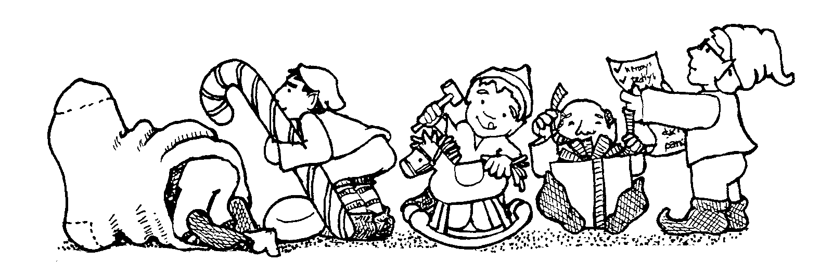

Artwork
Baking
Candles
Christmas Wreaths
Cutlery
Decorations
Honey
Homemade crafts
Jewellery
Knitted and Crocheted Items
Ornaments
Preserves
Woodworking
And much more...
Plus a Penny Table!

Refreshments provided by the
Spanish Medical Committee

All proceeds from this event go to the
Medical Building Fund.

Psst... Don’t forget to visit the Penny Table!

For more information, call: (705) 844-2300

